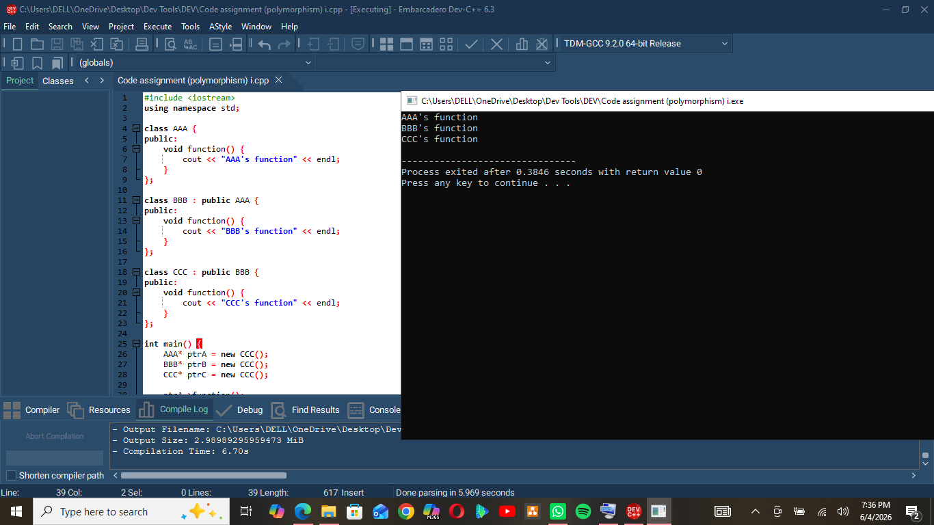
- ptrA is an AAA*, so AAA::function() is called.
- ptrB is a BBB*, so BBB::function() is called.
- ptrC is a CCC*, so CCC::function() is called.
- Since function() is not virtual, the function called depends on the pointer type, not the actual object type (CCC).

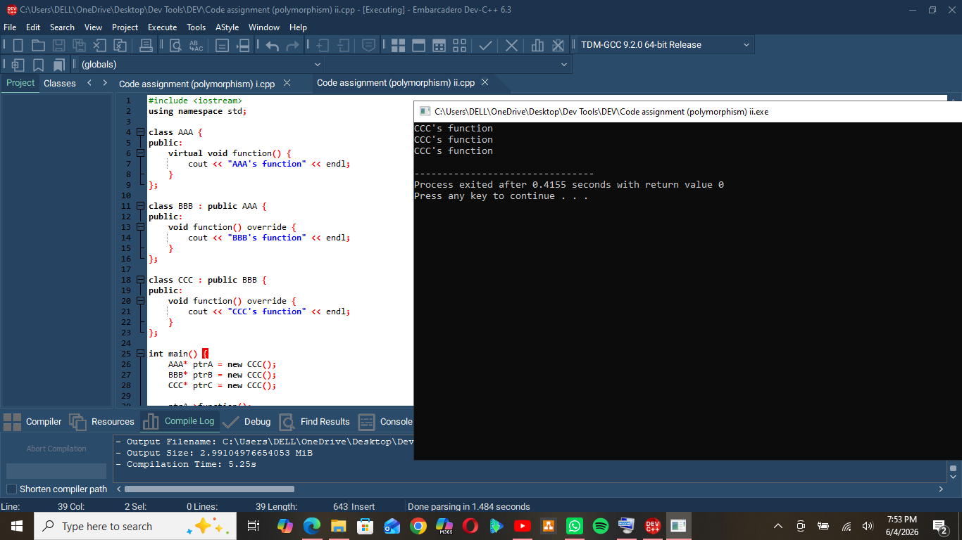
- function() is declared as virtual in the base class AAA.
- BBB and CCC override the function.
- All three pointers actually point to a CCC object (new CCC()).
- With virtual functions, the function called depends on the actual object type (the pointed object), not the pointer type.
- Therefore, all three calls execute CCC::function().

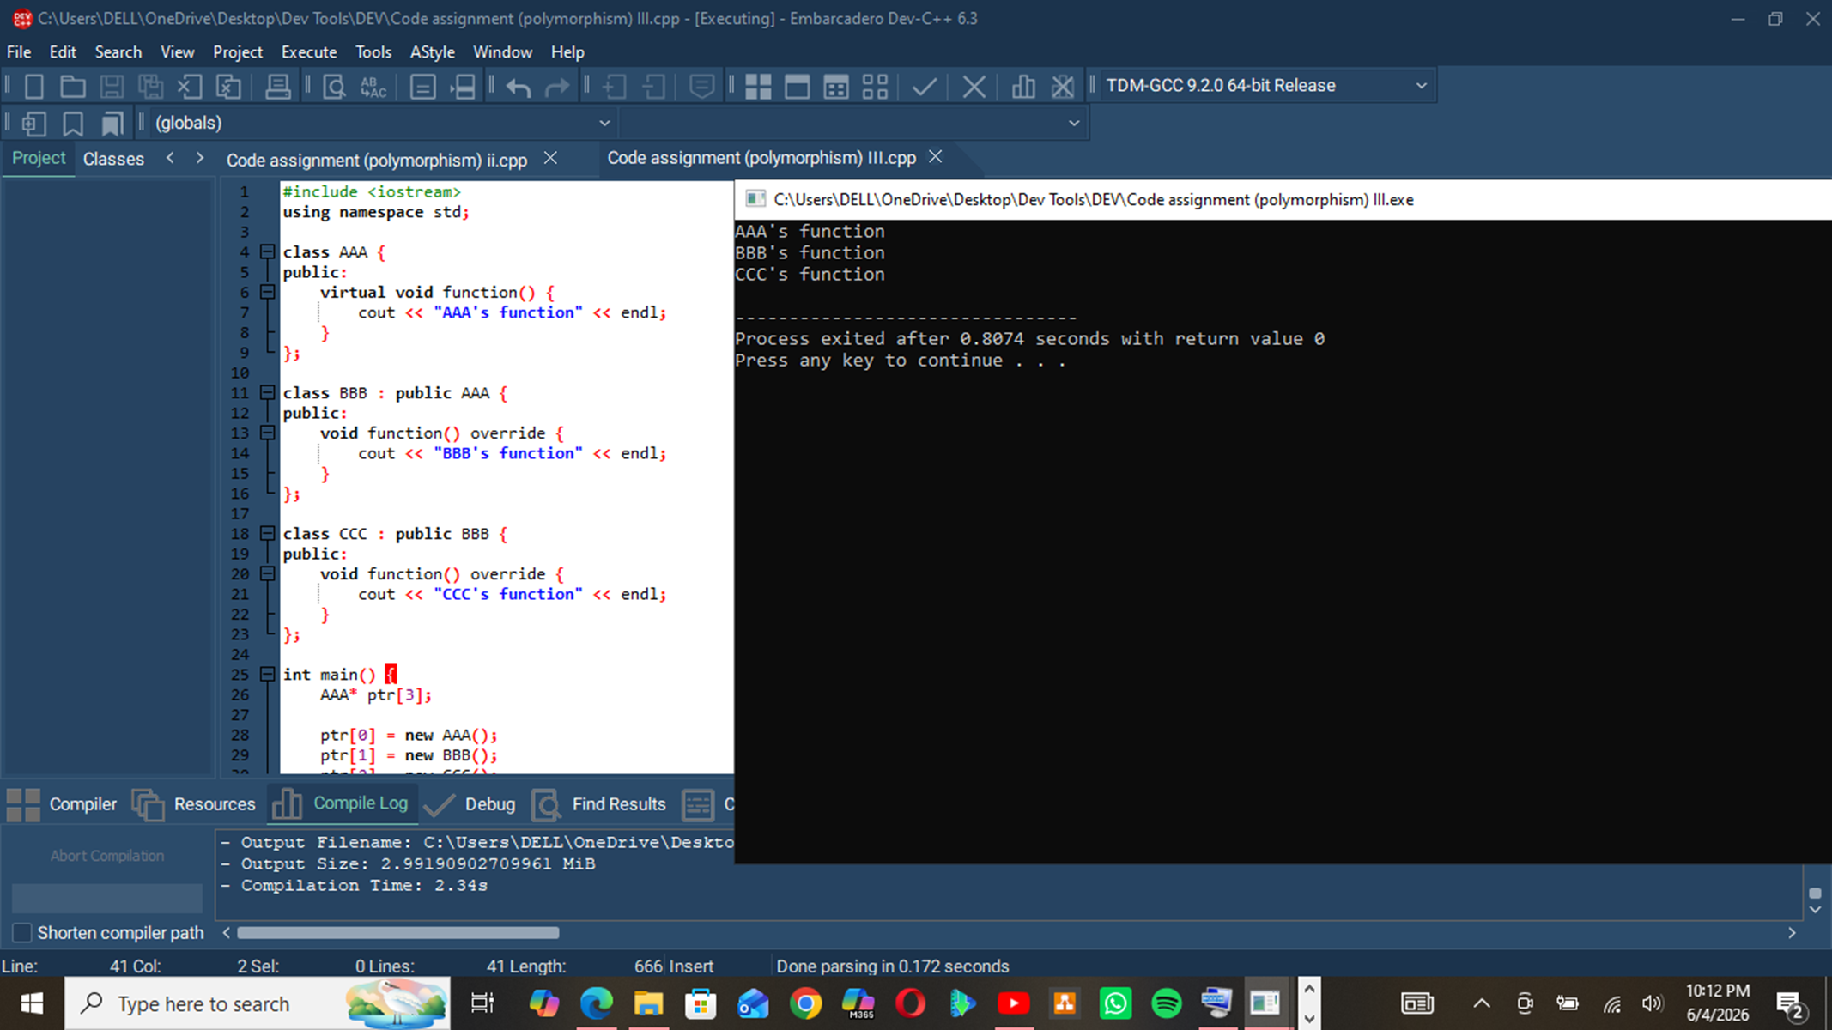
ptr is an array of base-class pointers (AAA*).
- Each element points to a different object type:
  - ptr[0] → AAA
  - ptr[1] → BBB
  - ptr[2] → CCC
- Since function() is virtual, the call is resolved according to the actual object type at runtime.
- The same operation (ptr[i]->function()) produces different results depending on the object being pointed to.

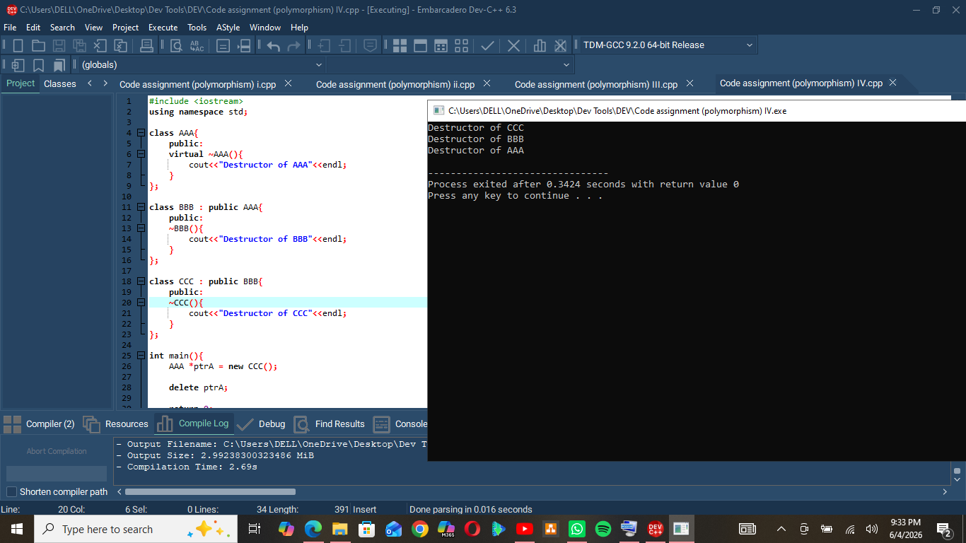
- AAA is the base class with a virtual –AAA() destructor.
- BBB inherits from AAA, and CCC inherits from BBB.
- In main(), we create a CCC object using an AAA* pointer(ptrA).
- Then we delete ptrA.

